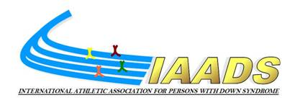

IAADS Membership application form

This form should be used by all associations seeking membership of IAADS. This form should be completed in English. All parts should be completed. Once complete, the form should be sent to the IAADS Secretariat. The application will be considered by the Board of IAADS.

Application form
Country
Name of applicant (national organization)
Address
Phone (including international dialing code)
Fax
E-mail
Website
Contact (name)

Other Informations:
Name of the President of the organization
Name of the Secretary of the organization
Have you a formal constitution ?
Have you agree to comply with the World Anti-Doping Code ?
Is your application supported by National Paralympic Committee ?
Is your application supported by National Sport Council or recognized Government Department for Sport ?

This application should be signed by the President and one other Federation Official.
Signed of the President >

Signed of one other Official >

_______________________________________________________________________________
Return all the documents to IAADS Secretariat > mary.russiello@iaads.info

